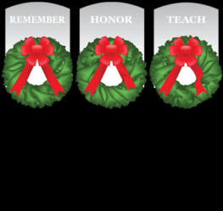

Dear Class and Chapter Officers and friends of USNA,

Please forward to your classmates and fellow alums via social media if you would

I am reminded every time I walk through USNA of the sacrifices that so many have made for our freedoms, for the pain each family member endures as they see their loved one’s name etched on stone and feel the loss of a child, father, mother, grandparent, classmate, loved one.

I don’t want to forget those that have gone before. By saying their names, by placing a wreath, and by hearing their stories, we continue to honor these great Americans. Please help us to honor these hero’s by sponsoring a wreath or two this year. Wreaths across America has made this possible for the last 10 yrs. By providing us the donated wreaths, transportation of those wreaths and the administrative technology to accomplish this. Because of your generous donations we have for 8 years filled the cemetery and columbarium, please help us to do this again this year.

By going to: wreathsacrossamerica.org/md0011 (this site allows us to automatically buy two and get a third for free)

-Click on Red “sponsor wreaths”, then follow prompts.

If you would like to mail a check, use the address as follows:
Wreaths Across America
PO Box 249
Columbia Falls, Me 04623
Write check to Wreaths Across America and PLEASE use MD0011 on memo section of check

Or scan the QR code with your smartphone:

We are asking for 2800 wreaths this year, to honor those we miss.

Once again, the class of 1981 will be our sponsor in this effort. If you have any questions on its validity, please contact the Class of ’81 president, Kevin Haney, at kjhaney2@me.com.

I am more than glad to answer any questions you may have.

The ceremony will take place on Friday December 9, 2022 time to be determined. Check back with me, or the web site listed above for any updates. All are welcomed to participate in the wreath laying and this moving ceremony to honor and remember.

Very Respectfully,
Carol Turman
Coordinator Wreaths Across America USNA
2430 Kemper Rd
Crofton, Md.21114
rhturman@comcast.net
h-410-451-4490
c-443-336-6541

